Design of Jig and Fixture to Improve Precision in Go-Kart Chassis Assembly

Fauzil Azhim Asysyauqi¹, Ahmad Nur Faiz², Arka Dwi Prasetya³, Sanurya Putri Purbaningrum⁴
^{1,2,3,4} Automotive Engineering Technology Study Program, Polytechnic STMI Jakarta, Jl. Letjen Suprapto No. 26, Jakarta 10510, Indonesia

ARTICLE INFO |  | ABTRACT
Received : 24 Juny 2025  Revised : 29 July 2025  Published : 30 November 2025 |  | This study is motivated by the low level of precision and consistency in the gokart chassis assembly process, which is still carried out manually without the use of specialized supporting tools. This condition may cause misalignment and positional inaccuracies between components during welding operations. The purpose of this study is to design a jig and fixture system as a supporting tool for gokart chassis assembly. The research method includes needs identification, design development using CAD software, design analysis, and design finalization. The result of this study is a jig and fixture design consisting of a base table, locator system, and integrated clamping mechanism. The materials used are SS400 steel for the jig and fixture structure and AISI 4130 for the gokart chassis. The locator and clamping systems were designed to maintain workpiece position and stability during assembly and welding processes. The developed jig and fixture design can be used as a reference for the development of chassis assembly support systems in automotive manufacturing applications.
KEYWORDS
Jig and fixture, gokart chassis, precision, assembly, manufacturing
CORRESPONDENCE
E-mail Correspnding Author:
fauzilazhim0206@gmail.com
E-mail Co-Author:
ahmadnurfaiz006@gmail.com
arkadwiprasetya0@gmail.com
sanuryaputri.p@kemenperin.go.id

This is an open access article under the CC–BY-NC license


INTRODUCTION
Go-kart chassis is the main component that functions as the supporting structure of the entire vehicle system, thereby requiring a high level of precision in terms of geometry, alignment, and structural strength (Azmi et al., 2024). Dimensional accuracy and alignment between components greatly affect vehicle performance, stability, and safety during operation (Safril & Azmi, 2025). Kishore et al. (2026) stated that chassis design plays an important role in determining force distribution, vibration absorption, and load transfer during acceleration, braking, and maneuvering conditions, thus requiring a strong and stable structure. Meanwhile, JAGTAP et al. (2021) explained that chassis design should consider wheelbase, track width, torsional rigidity, component placement, as well as the implementation of Computer Aided Design (CAD) and Finite Element Analysis (FEA) to minimize fabrication errors and ensure structural stability under various loading conditions. Therefore, the assembly process of a go-kart chassis requires a high level of accuracy to ensure that the resulting geometry and structural quality conform to the specified design requirements.

However, in practice, the assembly process of go-kart chassis is still commonly carried out manually without the use of specialized tools capable of maintaining component position and alignment consistently. According to Prianto et al. (2024), manual assembly processes without fixture systems are highly dependent on operator skills and potentially lead to misalignment, dimensional deviations, and inconsistent welding quality. These conditions may affect chassis geometric accuracy and cause structural deformation due to uneven heat distribution during welding processes. Previous studies reported that thermal distortion during welding processes may lead to dimensional inaccuracies and residual stresses in welded structures (Afazov et al., 2023). In addition, Naksri et al. (2021) reported that unstable workpiece positioning during welding may result in distortion, joint displacement, and material deformation caused by uncontrolled heat distribution, thereby reducing welding quality and increasing the need for rework. Therefore, a system capable of maintaining workpiece stability and positional consistency during assembly and welding processes is required.

One of the solutions that can be implemented to improve assembly accuracy and consistency is the application of jig and fixture systems. Fiedler et al. (2024) explained that jig and fixture are manufacturing support tools designed to maintain the position, orientation, and stability of workpieces during fabrication processes, allowing production activities to be performed repeatedly with more uniform results. In addition, locator and clamping systems in jig and fixture are utilized to maintain component positioning and stability during assembly operations. Previous studies also showed that the positioning of locator and clamp systems in a fixture significantly affects workpiece deformation during manufacturing processes, therefore fixture layout optimization is required to improve positioning accuracy and minimize dimensional deviations during assembly and welding operations (Qazani et al., 2022). Several studies also highlighted that fixture systems contribute significantly to reducing vibration and deformation while improving dimensional accuracy and machining stability during manufacturing processes (Liu et al., 2022). Kiraci et al. (2023) stated that proper fixture design and clamping sequence can reduce dimensional variations and improve consistency in assembly and inspection processes of manufactured components. Furthermore, Kadam et al. (2024) demonstrated that welding fixtures play an important role in maintaining component positioning accuracy during welding processes, thereby improving joint quality and fabrication accuracy. Along with the advancement of manufacturing technology, jig and fixture design processes are currently widely supported by Computer Aided Design (CAD) systems to improve design accuracy and facilitate assembly simulations before fabrication is conducted.

Several previous studies have discussed go-kart chassis design and analysis as well as the implementation of jig and fixture systems in manufacturing processes. Mihalic et al. (2023) investigated the design and development of a go-kart chassis based on structural analysis to improve vehicle safety and stability. Another study by Ramteke & Nambiar (2022) explained that material selection and finite element analysis (FEA) significantly influence chassis deformation behavior, factor of safety, and overall vehicle performance and reliability. Meanwhile, studies related to jig and fixture systems have mainly focused on improving manufacturing repeatability, reducing dimensional variations, and enhancing production efficiency in general industrial components. Studies on modular and reconfigurable fixture systems also indicate that fixture flexibility, structural rigidity, and adaptable layouts are important factors in supporting manufacturing efficiency and accommodating various workpiece geometries (Gaspar et al., 2021). Nevertheless, studies specifically addressing jig and fixture design for go-kart chassis assembly remain limited, particularly those considering the integration of locator and clamping systems according to chassis geometry and workpiece stability during welding processes.

Based on these problems and previous studies, this research focuses on the design of a specialized jig and fixture system for go-kart chassis assembly by considering workpiece stability during welding operations. The novelty of this research lies in the integration of locator and clamping systems designed according to go-kart chassis geometry to maintain component alignment during assembly and welding processes. In addition, the developed jig and fixture design also considers base table structural rigidity and operator ergonomics during operation. Through this approach, the assembly process is expected to achieve better precision, consistency, and efficiency compared to conventional manual assembly methods without specialized supporting tools.

This research aims to design and develop a jig and fixture system as a supporting tool for go-kart chassis assembly processes in order to improve assembly precision, stability, and consistency. The design applies locator and clamping systems to maintain component positioning during assembly and welding operations. The contribution of this study is the development of a jig and fixture design that can be used as a reference for lightweight vehicle chassis assembly systems with improved dimensional accuracy, fabrication quality, and manufacturing efficiency.

METHOD

Determining Product Design
The initial stage of this research was determining the product design used as the object of study, namely the gokart chassis. The selection of this product was based on its compatibility with the worktable capacity and the complexity of the frame structure, which requires high precision during assembly. The chassis material used in this study was AISI 4130 chromoly steel pipe due to its high strength and relatively lightweight characteristics, making it suitable for vehicle frame applications.

Product Design Development
The next stage was developing the product design using CAD software (Autodesk Inventor). This design served as the primary reference for determining the jig and fixture requirements, particularly in defining support points, locator positions, and areas requiring clamping mechanisms. Based on the product design, the jig and fixture concepts were then developed by determining locator types, locator placement, clamping systems, and ergonomic considerations during assembly operations. The determination of locator positions was based on critical chassis geometry points that influence alignment and dimensional stability during the assembly process. Meanwhile, the clamping system was designed by considering load distribution, welding accessibility, and the ability to minimize workpiece displacement during fabrication processes. The designed concept had to ensure workpiece stability without interfering with welding processes (Gurning & Riadi, 2022).

Jig and Fixture Design Concept
The detailed design process was carried out by designing jig and fixture components using CAD software. The designed components consisted of frame tables, base tables, body locators, head locators, clamping systems, and other supporting components. After all components were completed, the assembly process was conducted to combine all parts into one integrated jig and fixture system. This process required high accuracy to avoid dimensional and positioning errors that could affect tool performance. The locator system in the jig and fixture design applies the 3-2-1 locating principle to limit the degrees of freedom of the workpiece and maintain consistent chassis positioning during assembly and welding operations.

Design Analysis
After the concept design stage, analysis was conducted to evaluate the compatibility between the jig design and the product geometry, assembly process requirements, and the ability of the jig fixture to maintain workpiece stability. This analysis aimed to ensure that the developed design could be effectively implemented in the gokart chassis assembly process.

Final Design
The final stage was design finalization, which involved evaluating the overall design results in terms of dimensions, component positioning, and technical drawing completeness. If any discrepancies were found, revisions were carried out until an optimal jig and fixture design was achieved and ready to be used as an assembly supporting tool.

RESULT AND DISCUSSION

Gokart Chassis Design
The results of this study are in the form of a jig and fixture design used as a supporting tool in the gokart chassis assembly process to improve precision, stability, and manufacturing efficiency. The product designed in this research is a gokart chassis using AISI 4130 chromoly steel pipe material. Structural analysis results indicate that AISI 4130 provides better performance due to lower deformation and higher safety factors compared to other materials (Sammangi et al., 2023). The designed gokart chassis is shown in Fig. 1.

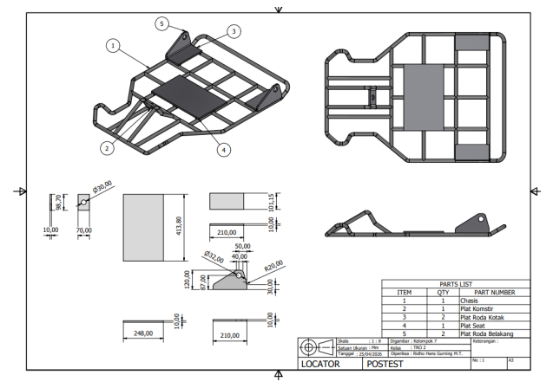
- Gokart Chassis Design
The primary material used in the jig and fixture is SS400 steel, which belongs to low carbon steel with carbon content below 0.17%. This material is widely selected because it has sufficient strength, high ductility, and excellent weldability, making it easy to fabricate (Oktaviandy et al., 2023). These characteristics make SS400 suitable for jig support structures that require stability and resistance to fabrication loads.
- Mechanical Properties of AISI 4130 and SS400
Material | Yield Strength (MPa) | Tensile Strength (MPa) | Density (g/cm³) | Characteristics
AISI 4130 | 435 | 670 | 7.85 | High strength, lightweight, good weldability
SS400 | 254 | 400-510 | 7.85 | Good weldability, structural rigidity, economical

The selection of AISI 4130 for the chassis was based on its high strength-to-weight ratio, making it suitable for lightweight vehicle frame applications. Meanwhile, SS400 was selected for the jig and fixture structure due to its good weldability, adequate structural rigidity, and cost efficiency for fabrication processes.

Locator and Clamping System Design
The developed jig and fixture design applies the basic principles of locating and clamping to limit the degrees of freedom of the workpiece. The locator system consists of body locators and head locators strategically positioned on critical sections of the chassis. Locator placement was determined by considering the product geometry to ensure consistent workpiece positioning during assembly processes. The locator and clamping system design is shown in Fig. 2.

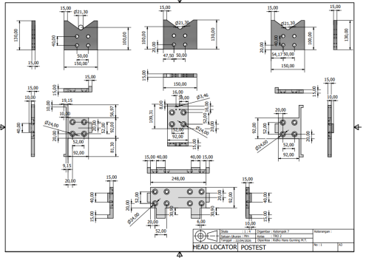
- Locator and Clamping System
The use of multiple locators at critical points allows better load distribution and minimizes displacement during welding operations. This contributes to improved dimensional accuracy, production consistency, and assembly efficiency. Previous research by Safril et al. (2024) also demonstrated that the implementation of production support systems can improve productivity in automotive manufacturing processes. In addition, the clamp mechanism functions as a locking system to maintain workpiece stability against external forces generated during fabrication processes.

Base Table Design
The base table is the main component in the jig and fixture system that functions as a support structure for all assembly elements. The base table design was developed by considering structural rigidity, stability, and ease of assembly. The structure uses a combination of steel frame construction and SS400 plates to balance strength and cost efficiency. The rigid structure minimizes deformation during manufacturing processes, ensuring that locator positions and workpiece alignment remain stable. The base table design developed in this research is shown in Fig. 3.

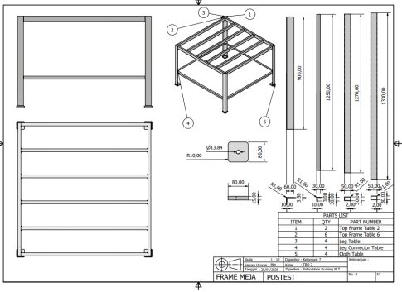
- Base Table Design
Additionally, the use of adjustable feet at the bottom of the table allows adaptation to uneven floor surfaces. This feature is important to maintain worktable balance because surface misalignment can affect workpiece positioning and reduce dimensional accuracy. From a manufacturing perspective, the modular design also considers ease of assembly and maintenance. The use of modular components allows for repair or replacement of specific parts without dismantling the entire system.

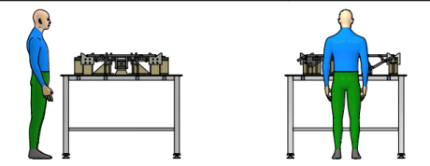
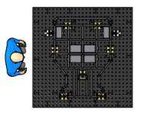
- Operator Position During Welding Process
The operator welding position during the assembly process is shown in Fig. 4. Operator position analysis was conducted to evaluate the level of comfort and work efficiency during the use of the jig and fixture system in the gokart chassis welding process. Gurning et al. (2025) stated that the health aspect showed the highest increase (12%), indicating that the understanding and implementation of occupational health and safety (K3) have a direct impact on workers’ physical well-being. The operator posture while performing welding operations in the middle section of the chassis remained relatively ergonomic, although there was a slight tendency toward a bending position. This condition is still considered acceptable because it does not require extreme posture adjustments and does not significantly hinder operator movement during the working process. The base table design used in this study has sufficient height and structural stability, allowing the operator to work in a relatively balanced position. In addition, the placement of locators and clamps does not obstruct the working area, thereby providing adequate space for the operator to perform assembly and welding activities efficiently.

CONCLUSION
Based on the results of this study, a jig and fixture design for gokart chassis assembly has been successfully developed, consisting of a base table, locator system, and clamping mechanism. The developed design applies locating and clamping principles to maintain workpiece position and stability during assembly and welding processes. In addition, the base table structure and adjustable feet were designed to improve operational stability and provide adequate operator accessibility during fabrication activities. The resulting jig and fixture design can be used as a reference for the development of chassis assembly support systems in automotive manufacturing applications.

REFERENCES
Afazov, S., Mistry, K., & Uzunov, K. (2023). Welding simulation of railway bogie frame side beam : Analyses of residual stresses , clamping forces , distortion and prediction of fatigue S-N curves. 237(1), 33–40. https://doi.org/10.1177/09544097221094986
Azmi, W. H., Sharif, M. Z., & Zawawi, N. N. M. (2024). INTERNATIONAL JOURNAL OF AUTOMOTIVE AND MECHANICAL ENGINEERING The Tribology Evaluation on a Four-Ball Tribometer Lubricated by Al 2 O 3 / PAG Nanolubricants. 21(1), 11055–11063.
Fiedler, F., Ehrenstein, J., Holtgen, C., Blondrath, A., Schaper, L., Goppert, A., & Schmitt, R. (2024). Jigs and Fixtures in Production : A Systematic Literature Review. 72(July 2023), 373–405. https://doi.org/10.1016/j.jmsy.2023.10.006
Gaspar, T., Kovac, I., & Ude, A. (2021). Optimal layout and reconfiguration of a fixturing system constructed from passive Stewart platforms. 60(May), 226–238. https://doi.org/10.1016/j.jmsy.2021.05.020
Gurning, R. H., Arohman, A. W., & Shalihah, A. R. (2025). Sosialisasi k3 dan 5r pada bengkel may car bodyworks. 1, 28–36.
Gurning, R. H., & Riadi, A. (2022). Dwelling Time Analysis Using Dynamic System Model in the Implementation of National Logistics Ecosystem at Port Jakarta International Container Terminal. 8–13.
JAGTAP JAGTAP, P. S. T., WATHARKAR, P. B., CHAVAN, P. R., DHALE, R. B., & KORE, S. S. (2021). DESIGN, ANALYSIS AND MANUFACTURING OF GO-KART CHASSIS Prof. March, 24–33. https://repo.ijiert.org/index.php/ijiert/article/view/1606
Kadam, G., Nagarajan, B., Mirji, V., & Sawant, S. (2024). Design of Rigid-Locking Variable-Angular-Span Welding Fixture †.
Kiraci, E., Palit, A., Attridge, A., & Williams, M. A. (2023). The effect of clamping sequence on dimensional variability of a manufactured automotive sheet metal sub-assembly. 7543. https://doi.org/10.1080/00207543.2022.2152897
Kishore, K. Y., Susmith, V., Mohan, C., Naik, V. B., & Deniel, T. J. (2026). Vibrational and Computational Analysis of Gokart Chassis. 2(1), 89–100.
Liu, H., Wang, C., Li, T., Bo, Q., Liu, K., & Wang, Y. (2022). Fixturing technology and system for thin-walled parts machining : a review. 17(4).
Mihalić, T., Hoster, J., Tudić, V., & Kralj, T. (2023). Concept Design and Development of an Electric Go-Kart Chassis for Undergraduate Education in Vehicle Dynamics and Stress Applications. Applied Sciences (Switzerland), 13(20). https://doi.org/10.3390/app132011312
Naksri, C., Chuchom, S., & Chaiprapat, S. (2021). Design of Fixture for Welding. https://doi.org/10.1088/1757-899X/1163/1/012007
Oktaviandy, N. R., Kardiman, & Hanafi, R. (2023). EFFECT OF PREHEAT TEMPERATURE VARIATION WITH COOLING MEDIA ON MECHANICAL PROPERTIES IN WELDING SS400 STEEL. 17(2), 130–142. https://doi.org/10.24853/sintek.17.2.130-142
Prianto, B., Haryudiniarti, A. N., Gustany, E. W., Restuasih, S., & Zulhamidi. (2024). Improving the Assembly Time of a Plate Cover Product Through Fixture Design. 03(01), 27–33. https://doi.org/10.56904/j-gers.v3i1.84
Qazani, M. R. C., Parvaz, H., & Pedrammehr, S. (2022). Optimization of fixture locating layout design using comprehensive optimized machine learning. The International Journal of Advanced Manufacturing Technology, 2701–2717. https://doi.org/10.1007/s00170-022-10061-1
Ramteke, S., & Nambiar, V. (2022). Material Selection Methodology for a Go-kart Chassis using FEA and Weighted Decision Matrices. 13(02), 539–550.
Safril, S., & Azmi, W. H. (2025). Investigation of different compressor speeds to improve the performance of residential air conditioning system using hybrid nanolubricant. 19(1), 10554–10564.
Safril, Wirandi, M., Sumasto, F., Imansuri, F., Fauzi, W., & Aji, R. M. P. (2024). Improvement productivity analysis in the application of electro-pneumatic for production of automotive components. AIP Conference Proceedings, 3093(1), 70001. https://doi.org/10.1063/5.0248567
Sammangi, D. K., Kayathi, L. Y., Kanaparthi, J., Kutcherlapati, R. A. V., & Sarimalla, R. (2023). A study on structural behaviour and vibrational characteristics of a go-kart chassis. 01042.

-This page intentional to be blank-

