Research Article

DESIGN OF BENDING DIES FOR BRACKET REAR SPRING FRONT 2 BASED ON CAE SPRINGBACK ANALYSIS
Ridho Hans Gurning¹, Abdul Wahid Arohman¹, Edwin Sahrial Solih¹, Sanurya Putri Purbaningrum¹, Teguh Fathurohman¹
¹ Polytechnic STMI Jakarta, Jl. Letjen Suprapto No. 26, Cempaka Putih, Central Jakarta, Indonesia, 10510

ARTICLE INFO |  | ABTRACT
Received : 16 May 2025  Revised : 24 Januari 2026  Accepted : 26 Agustus 2026 |  | This study redesigned the dies bending of automotive components Bracket Rear Spring Front 2 using numerical simulation based on Computer Aided Engineering (CAE), in order to overcome the decrease in geometric precision due to the springback phenomenon. The analyzed components showed a significant decrease in accuracy, from 98.72% to 53.84%, which was identified through fixture checking measurements and 3D metrology. Simulations were performed on four bending angle variations (88.5°, 89°, 90°, and 90.92°) to evaluate final angle deviation and dimensional accuracy. The results showed that an angle of 88.5° resulted in the highest accuracy of 92.31%, with a minimum deviation to the shape of the design. Validation is carried out through comparison of the simulation results with the actual parts on the surface clearance and trimming line parameters, which shows high conformity. Statistical analysis yielded a Root Mean Square Error (RMSE) value of 0.67° and a coefficient of accuracy variation of 3.12%, indicating consistency between configurations and the effectiveness of the approach. These findings reinforce the role of CAE as a prescriptive tool in industrial anniversary redesign, particularly for older tooling that lacks technical documentation. This approach not only improves manufacturing accuracy and efficiency, but can also be replicated for tooling rehabilitation in the process of forming high-precision metals in the automotive sector.
KEYWORDS
Dies Bending, Numerical Simulation, Springback, Computer Aided Engineering, Front Spring Back Bracket 2
Korespondensi
ridhohans@stmi.ac.id

INTRODUCTION
The development of modern manufacturing technology, particularly in the automotive sector, has demanded an increasingly sophisticated approach to the metal forming process. One of the most crucial processes is the forming of sheet metal through the bending method, which is widely used in the production of structural and functional components of vehicles due to its efficiency in cost and its ability for mass production (Altan et al., 2005). However, the bending process has a fundamental challenge in the form of springback, which is the tendency of metal materials to partially return to their original shape due to elastic recovery, which leads to dimensional inaccuracies and decreased product quality (Yang et al., 2012; Buang et al., 2015). Springback problems are not just small tolerance deviations, but can have a significant impact on assembly precision and lead to wastage due to a high number of rework or product failures. This problem is very critical, especially in components with tight dimensional tolerances, such as the rear spring front 2 bracket, which is a structural component of a vehicle that functions to connect the damper system to the vehicle frame. Based on the latest production data, the accuracy level of this component has decreased drastically from 98.72% to 53.84%, which is suspected to be caused by geometric changes due to uncontrolled springbacks during the bending process. The inspection results showed that the trimming line, surface line, and hole position did not match the reference sample, indicating geometric deformation due to the age of the dies that have been used for more than 27 years. Based on internal industry standards, dies with an accuracy below 65% or older than 10 years are mandatory (ASTM E290-14, 2014; company standards, 2023). The design of the dies and the integrity of the tool greatly determine the dimensional stability of the bending process. Conventional design methods that still rely on empirical and trial and error approaches are considered inefficient in the context of modern manufacturing. Therefore, a based simulation approach through Computer Aided Engineering (CAE) is becoming an increasingly reliable solution, as it allows predicting the deformation behavior of materials before the production process is physically carried out (Lakkannavar & Kattimani, 2014; Mat Dzahir et al., 2007). CAE, particularly through the finite element analysis (FEA) method, provides in-depth information on stress-strain distribution, springback tendencies, and optimal dies geometry design, thereby reducing design iteration cycles and production costs. Various previous studies have shown the effectiveness of integrating process simulation with dies design to reduce defects in metal formation. (Mat Dzahir et al., 2007), for example, showed that the integration between the formation simulation and the design of the dies was significantly able to control springback in complex automotive components. Similarly, (Wulan and Cahyaningtyas, 2023) applied a CAE-based approach in redesigning dies for the prop support components, which was proven to be able to improve the dimensional suitability of the final product. These studies reinforce the urgency of implementing CAE in the development of modern anniversaries. In response to the problems that occurred, this study aims to redesign the dies bending for the rear spring front 2 bracket component with a CAE simulation-based approach to control and minimize springback. Several bending angle parameters—i.e. 88.5°, 89°, 90°, and 90.92°—were evaluated through forming simulations to determine the most effective configuration. The simulation results showed that the bending angle of 88.5° provided the best final accuracy, with an increase in dimensional suitability from 53.84% to 92.31%, exceeding the company's quality threshold. In the context of this study, springback is operationally defined as the angular deviation between the designed bend angle and the actual angle after elastic recovery, which is measured through a checking fixture and 3D metrology coordinates. The new design includes 3D CAD models for CAM needs as well as 2D engineering drawings as a fabrication reference. This research not only contributes to improved product quality, but also offers a replicable framework for redesigning dies in similar applications. The significance of this research lies in its contribution to industrial practice through a systematic simulation-based design approach in addressing the springback problem that has long been a challenge in the metal forming process. By bridging the gap between theoretical analysis and practical realization, the study supports cost efficiency, manufacturing precision, and the sustainability of production tools in the automotive industry sector.

METHOD

Research Materials
The object of this study is the automotive component Bracket Rear Spring Front 2, which is part of the vehicle suspension system that functions to connect the shock absorber to the vehicle frame. This component was chosen because it experienced a significant decrease in accuracy in the production process, from 98.72% to 53.84%. This decrease was known through measurements with a checking fixture and Coordinate Measuring Machine (CMM) which identified deformations on the trimming line, surface line, and hole position. One of the main factors causing this discrepancy is springback, which is the elastic recovery effect of the metal after the bending process (Yang et al., 2012; Altan, Ngaile, & Shen, 2005). Springback is a common problem in sheet metal forming that can cause significant dimensional deviations in the final part.

The research materials include primary data in the form of direct measurement results on actual components, as well as secondary data such as technical specifications of old dies, press machine parameters, and the company's internal manufacturing tolerance standards (Misumi Corporation, 2007). The software used includes CAD (Computer Aided Design) for 3D modeling of dies, CAE (Computer Aided Engineering) for simulation of deformation due to the bending process, and CAM (Computer Aided Manufacturing) for simulation of the dies manufacturing process through CNC G-code programming. The application of this technology has proven effective for the development of precision dies and improving product accuracy in various previous studies (Mat Dzahir et al., 2015; Wulan & Cahyaningtyas, 2023). Precision measuring devices such as checking fixtures and CMMs are used in the final stage to validate the simulation results against the real shape of the parts produced, as also explained by Sudarmawan (2009) in a technical study on dies press technology.

Research Methods
This study uses a numerical experimental approach based on CAE (Computer Aided Engineering) with a prescriptive model that aims to provide a technical solution to the springback phenomenon, which is the tendency of metal to return to its original shape due to elastic recovery after the forming process. Springback often causes part geometry mismatch in precision manufacturing, especially in sheet metal bending processes (Yang et al., 2012; Altan, Ngaile, & Shen, 2005). The initial step in this study was to conduct direct observation and measurement of the actual part that was deformed using precision measuring instruments such as checking fixtures and Coordinate Measuring Machines (CMM). Based on the results of the initial evaluation, a redesign of the die geometry was carried out in 3D CAD (Computer Aided Design) format.

Next, a simulation of part formation using CAE based on the Finite Element Method (FEM) was carried out on four bending angle configurations: 88.5°, 89°, 90°, and 90.92°. This simulation aims to predict angular deformation and measure shape deviation from the initial design. Actual process parameters such as material elastic modulus, bending radius, and press force are calculated in detail in the simulation process, as explained by Dzahir et al. (2015) and Sudarmawan (2009) as key factors in controlling the accuracy of forming results. After all simulations are carried out, the results are compared with the actual shape of the part from 3D measurements, to determine the most optimal angle that produces the best geometric accuracy. Validation of the results is carried out using the data triangulation method through a comparison between simulation results, metrology data, and CAM documents, which strengthens the validity of this approach in automotive tooling applications (Wulan & Cahyaningtyas, 2023; Misumi Corporation, 2007).

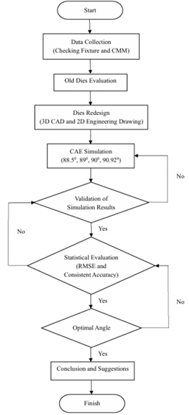
Fig. 1. Process Implementation Procedure
  - Data Analysis
The analysis was conducted by comparing the CAE simulation results to the actual part to measure the deviation of the shape and geometric accuracy. The evaluation used Root Mean Square Error (RMSE) and Coefficient of Variation (CV) to assess the stability and consistency of the bending angle configuration.

Visualization of the results in the form of section view images and accuracy improvement graphs reinforces that adjusting the die design to the bending angle is very important. This data is consistent with the research results of Altan (1998) and Sudarmawan (2009), which state that the elasticity of metal materials greatly affects the accuracy of the final shape results in the forming process.

Model Validation
Validation is performed through a triangulation technique approach, which includes a comparison between CAE simulation data, physical measurement results using checking fixtures, and verification of manufacturing results through CAM. This method aims to ensure that the simulation results are not only numerically valid, but also representative of real production conditions. This approach is in line with validation practices in manufacturing engineering recommended by Altan et al. (2005), namely integrating digital simulation with actual measurements to ensure the accuracy of tooling design.

Validation was carried out by comparing the simulation results with actual measurement data and CAM results in the form of G-code for CNC machines. Validation points were focused on three critical deformation parameters, namely surface clearance, trimming line, and hole position, as recommended by Misumi Corporation (2007) in the precision component inspection standard. To ensure consistency, measurements were carried out repeatedly using a Coordinate Measuring Machine (CMM) and carried out in a room with controlled temperature. This process refers to the principles of repeated validation as explained in the study by Wulan & Cahyaningtyas (2023), which states that precision measurement and data replication are crucial in proving the validity of CAE simulations in the context of automotive manufacturing dies redesign.

RESULT AND DISCUSSION

Problem Identification and Basis for Redesign
Based on initial observations of the Front 2 Rear Spring Bracket components, it was found that the dimensional accuracy decreased drastically from 98.72% to only 53.84%. The inspection results using a checking fixture and a three-dimensional coordinate measuring tool (CMM) revealed significant geometric deviations in the trimming line area, surface line, and hole position. Follow-up evaluation shows that the used dies have been in operation for more than 27 years, well past the recommended lifespan limit of 10 years according to industry standards. Material wear and repeated deformation are believed to be the main causes of the appearance of the phenomenon of excessive springback, as well as changes in bending angles that do not match the sample part. The new design was carried out using the Computer Aided Engineering (CAE) method and produced designs in 3D and 2D formats as shown in Figure 2 and Figure 3
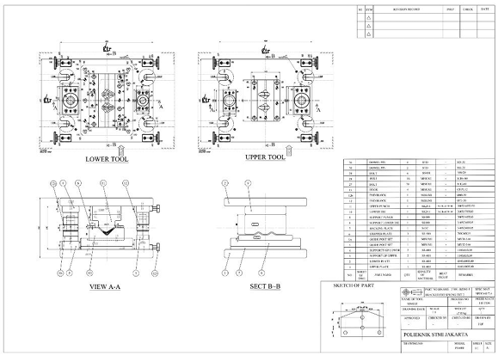
Fig. 2. Results of Designing Dies Bending

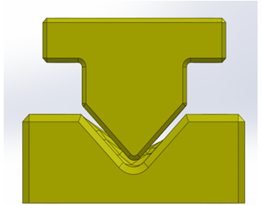
Fig. 3. Punch and Lower Die Design Results After CAE Analysis

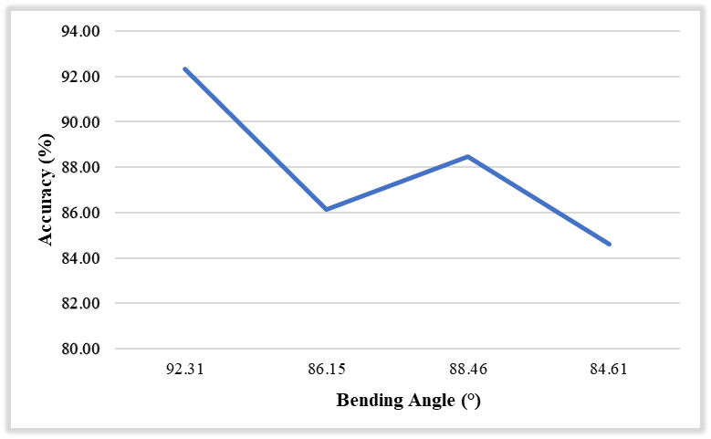
Fig. 4. Graph of the Relationship of Bending Angle with Accuracy

Analysis of Deviation and Consistency
Statistical analysis was performed to evaluate the stability of the simulation results. The angular deviation to the target was analyzed using Root Mean Square Error (RMSE) and coefficient of variation (CV) to determine irregularities between configurations.
- RMSE against target angles 90º:
$$RMSE=\sqrt{\frac{{{(90.02 - 90)}^{2} +{(89.45 - 90)}^{2} +({88.37 - 90)}^{2}{ + (89.12 - 90)}^{2}}^{}}{4}}$$
$RMSE=0,67$º
- Coefficient of variation for accuracy (%):
$CV = \frac{Std. Deviation Accuracy}{Average Accuracy}$ x 100%
CV = 3.12%

The small RMSE value indicates that all variations are still within the threshold of industrial technical tolerance. While a low CV shows that the simulation is quite consistent and stable. RMSE analysis was carried out against the 90° target because it is a geometric design reference that is an industry standard, measuring the effectiveness of pre-bending angles in achieving the final result according to the design, as well as valid and prevalent practices in CAE/manufacturing studies.

Formation Simulation Results Based on Bending Angle Parameters
The results obtained from the data that have been processed at the data processing stage are the results of software analysis, 3D and 2D dies bending design, and finally the CAM process of each dies component. Each parameter was tested to determine the actual angular deviation from the ideal design of the rear spring front 2 bracket part, focusing on the effect on springback defects. The following are the processing results of each data that has been processed based on four variations of bending angles (88.5°, 89°, 90°, and 90.92°) using the Computer Aided Engineering (CAE) simulation approach:

Table 1. CAE Simulation Results with Angle Variations
Bending Angle | Final Deformation (º) | Deviation to Angle | Accuracy (%)
90.92º | 90.02º | +0.92º | 84.61
90º | 89.45º | +0.55º | 88.46
89º | 88.37º | +0.63º | 86.15
88.5º | 89.12º | +0.62º | 92.31
The accuracy comparison carried out between before conducting the CAE simulation and after the simulation obtained an increase in accuracy from 53.85% to 92.31%. The resulting improvement in accuracy can be seen in the graph image in figure 5.
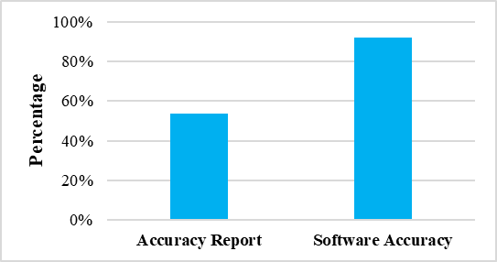
Fig. 5. Accuracy Improvement Graph
From the data above, it can be observed that the angle of 88.5° produces the highest accuracy which is 92.31%. This happens due to a correction to the elasticity of the material that causes springback. Sharper (smaller) corners tend to suppress the elastic effect so that the end angle of the part is close to the design specifications. This supports the theory that the selection of the right pre-bending angle can compensate for springback as described by Altan (1998) and Yang et al. (2012).

Verify Simulation Results with Sample Parts
To verify the results, a comparison was made between the simulation and the 3D sample part. The analysis of dimensional differences was carried out at three critical points: the trimming line, the surface line, and the hole position presented in figure 6 and figure 7.
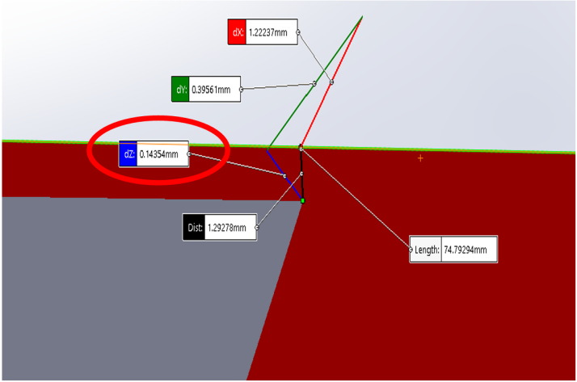
Fig. 6. Measurement of the Distance Comparison of the Farthest
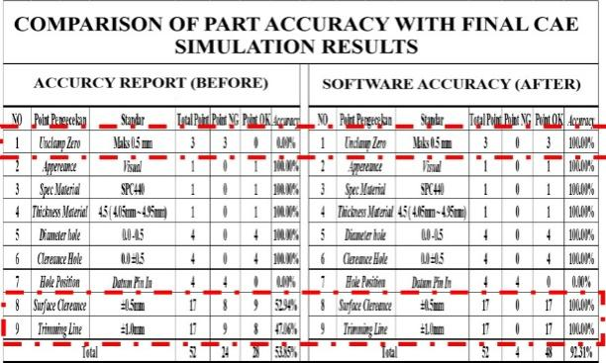
Fig. 7. Accuracy Comparison

Accuracy points that can be checked through software are unclamp zero surface, surface clereance, trimming line. Point checking Hole position cannot be done software because there is a special tool used to perform the checkThe results of the measurement of the farthest point comparison with the accuracy comparison show that the configuration with an angle of 88.5° is closest to the 3D sample profile, with minimal deviation to all reference lines. This shows the validity of the CAE simulation method in designing precise dies. This supports the previous literature that CAE is an efficient and prescriptive method in the development of metal-forming based products (Lakkannavar & Kattimani, 2014).

The increase in accuracy from 53.84% to 92.31% is a validation that the selection of bending angles in CAE simulations is crucial in overcoming springback problems. The advantage of this method is that it is able to reduce trial and error in the manufacturing process, while speeding up design iterations without sacrificing output quality. The novelty of this research lies in the practical approach based on CAE in part scenarios that have been in use for 27 years and have no previous design documentation.

Based on this study, the results and discussion present concrete solutions to the challenges of the automotive manufacturing industry related to the accuracy degradation of old parts and the springback phenomenon. These results also demonstrate the effectiveness of CAE-based digital manufacturing approaches for old tooling redesigns. The practical implication is that companies can reduce production costs by reducing the remanufacturing of dies through trial-error, as well as extending the life of tools through precision design. The implications of this entire study include: reduction of potential springback defects in the bending process, acceleration of the iteration of the CAE-assisted dies design, and increased tooling life and reduction of replacement frequency. A major novelty in this study is a practical approach that combines CAE analysis and direct validation of 3D sample parts used for more than 25 years, without the support of initial design documentation.

Industry Implications and Strategic Advantages
The application of CAE in this anniversary redesign not only provides a high-precision solution, but also reduces the need for manual design iterations that are time-consuming and cost-consuming. By increasing the accuracy of the part by up to 92.31%, the production process becomes more efficient and the risk of rework is significantly reduced. This approach also shows the potential to be replicated in similar scenarios—i.e., revitalization of old, undocumented tooling.

These findings reinforce previous literature (Altan, 1998; Lakkannavar & Kattimani, 2014) that springback control requires integration between numerical simulation and experimental validation. The study adds applicative context through real case studies and relevant metrological validation parameters in manufacturing practices.

CONCLUSION
This study aims to develop a numerical simulation-based dies bending redesign approach to overcome the springback problem that causes a decrease in geometric precision in automotive components of Bracket Rear Spring Front 2. Based on the results of the analysis, the Computer Aided Engineering (CAE) approach has proven to be effective in predicting deformation due to the reverse elasticity of materials and providing a precise, efficient, and replicable design solution. By testing four variations of bending angles (88.5°, 89°, 90°, and 90.92°), it was found that the 88.5° angle gave the most optimal result, namely geometric accuracy of 92.31%, a significant increase from the initial accuracy of 53.84%.

Quantitatively, the simulation results show an angular deviation to the design target of 90° within a range that is still acceptable to industry standards. Root Mean Square Error (RMSE) analysis of 0.67° and coefficient of accuracy variation of 3.12% indicate that the method used not only results in a high accuracy increase, but is also consistent across configurations. Validation using actual measurements of real parts through fixture checking and 3D metrology coordinates strengthens the reliability of the simulation results, especially in the trimming line and surface clearance areas. The high compatibility between the simulation data and the measurement results confirms that the CAE model can be used as a credible tooling prediction and design tool in the context of mass production of the automotive industry.

The main contribution of this research lies in the development of a practical framework for revitalizing old tooling that has lost technical documentation. The CAE-based approach applied not only results in a redesign of the dies to specifications, but also minimizes the need for physical iterations, speeds up the design cycle, and reduces costs due to manufacturing errors. The novelty of this research lies in the systematic application of parametric simulations to determine the optimal pre-bending configuration of real industrial cases, which is rarely found in conventional literature. In addition, this approach can be adapted to various other metal formation cases that face similar problems.

As a follow-up, it is recommended that the design of the simulated anniversary be realized in the form of a physical prototype to be tested in the actual production environment. Long-term performance evaluations need to be performed to assess tooling stability and wear in a continuous production cycle. In addition, the development of a technical documentation management system such as Product Lifecycle Management (PLM) is highly recommended to prevent the loss of design information in long-lived tooling. Thus, this research not only makes a theoretical and methodological contribution, but also has strong implementability potential in the high-precision-based manufacturing industry.

REFERENCES
Agus Dwi Anggono. (2018). Teknologi CAD/CAM/CAE dalam industri manufaktur.
Advisor, A., Made, I. I., Batan, L., & Eng, M. (n.d.). Application of CAM NX machining for manufacturing process of die for 20 millimeters caliber cartridge case (Final project-TM 141585).
Hilman, A. (2011). Perancangan dan analisis stamping dies untuk pembuatan produk bracket bumper dengan proses press multi forging.
Idiar. (2016). Rancang bangun cetakan deep drawing cup silindris untuk selongsong peluru caliber 20 milimeter [Skripsi tidak diterbitkan]. Teknik Mesin ITS.
IMDIA. (2011). Text ujian sertifikasi design die press.
Lakkannavar, V. A., & Kattimani, K. D. (n.d.). Modelling and failure analysis in sheet metal forming process using CAE. Retrieved from https://www.ijert.org
Mat Dzahir, M. A., Hussein, M., Supriyo, B., Tawi, K., Kob, S., & Mat Dzahir, M. A. (2015). System identification of clamping force controller for secondary pulley of electro mechanical dual acting pulley continuously variable transmission (EMDAP CVT). Jurnal Teknologi, 77(1). https://doi.org/10.11113/jt.v77.6667
Misumi Corporation. (2007). Misumi press dies standard part technical specification (1st ed.).
PT Inti Pantja Press Industri, Dept Marketing & Engineering, Div Engineering. (2018). Design policy engineering.
Suchy, I. (2006). Handbook of die design. McGraw-Hill.
Sudarmawan, R. (2009). Teknologi press dies. Penerbit Kanisius.
Tanshin, M. (2011). Press die design basic textbook (I. M. & D. I. Association, Eds.).
Wróbel, I. (2014). Biographical notes. Acta Mechanica Slovaca, 82(1), 82–86. https://doi.org/10.1515/mopa-2014-0012
Yang, H., He, Y., Li, H., Fan, H., & Zhan, M. (2012). Advances and trends on tube bending forming technologies. Chinese Journal of Aeronautics, 25(1), 1–12. http://dx.doi.org/10.1016/S1000-9361(11)60356-7

